- DR. JONATHAN VALVANO: In this video, we will
- demonstrate the fundamental concepts of sampling.
- Here is a slide plot similar to the one you will use in lab.
- The analog signal is shown in the plot as the blue signal.
- And the data points are sampled as plotted by the red signal.
- DR. RAMESH YERRABALLI: So if the sampling were done faithfully
- to capture the signal, then the red line would track the blue line.
- That is a digital capture would capture the analog signal faithfully.

- So what if it doesn't track?
- DR. JONATHAN VALVANO: Then we get the wrong answer.
- So there are many ways in which the digital samples
- are different from the analog samples.
- The first is amplitude quantization.
- That means that at every point, the only choices
- we're going to have are discrete values between some number
- and some other number.

- Additionally, there is an amplitude range.
- In other words, there is a finite difference, a finite range,
- between which our samples must exist.
- So in our case, that's going to be 0 to 3 volts.

- The third is time quantization.
- Because we have to collect the data into a computer,
- there will be a finite time.
- In this case, we can see where the times are,
- a finite time, that the data are sampled.
- And furthermore, one more, and that is, the time interval is fixed.
- In other words, no matter how much memory we have in the computer,
- there's always a finite amount of it, which
- means that we can only represent the data from some minimum time
- to some maximum time.
- And these are the four limitations that exist in sampling.
- So let's review the components of the data acquisition system.
- DR. RAMESH YERRABALLI: This is the system
- that you're going to build for Lab 14.

- DR. JONATHAN VALVANO: It begins with something we want to measure.
- In our case we're going to measure distance.
- This distance is converted by a sensor.

- The sensor is connected to a circuit, to give us a voltage.

- The voltage will then be input to the analog
- to digital converter, which will give us a number, a 12 -bit number.
- Software, that we write, will convert that number
- into something that means something, to a distance.
- And lastly we're going to output those results to a display, which in our case
- will be the UART.
- DR. RAMESH YERRABALLI: Here we're showing you the data flow diagram.
- So the data initially is resistance, which
- gets converted to a voltage, which then gets converted to a number.
- And eventually it gets converted to a string which is displayed on the UART.
- DR. JONATHAN VALVANO: Exactly.
- So let's look at the ADC parameters, the fundamental behavior
- of the analog to digital converter.
- The first is Precision.
- The precision is the number of different alternatives.
- How many different values can we measure?
- In our case, it's going to be 12 bits, or 4,096 alternatives.
- The second will be the Range.
- In other words, what is the minimum to maximum voltage that we can measure.
- In our case it will measure 0 to 3 volts.
- And putting those two together, we can ask what is the Resolution?
- In other words, the resolution is the smallest change in voltage
- that can be reliably detected.

- These three parameters are related.
- In other words, the resolution is a function
- of the range divided by the precision in alternatives.

- In our particular case, the range is 3 volts
- minus 0 volts, divided by a precision of 4,096.
- And this will result in a resolution of 0.7 millivolts.
- So any change in voltage here, greater than 0.7 millivolts,
- is detectable by the analog to digital converter.
- DR. RAMESH YERRABALLI: So in summary then,
- if we have a really good sensing system, and an analog to digital converter that
- has high resolution, what we're saying is
- that it has it can convert and measure even the smallest change possible.
- So the higher the resolution, the better the sensor, the more expensive
- it's going to get.
- DR. JONATHAN VALVANO: Exactly.
- All right.
- Next we're going to see how the A to D converter works in our microcontroller.

Go back to start of transcript.
An analog to digital converter (ADC) converts an analog signal into digital form, shown in Figure 14.1. An embedded system uses the ADC to collect information about the external world (data acquisition system.) The input signal is usually an analog voltage, and the output is a binary number. The ADC precision is the number of distinguishable ADC inputs (e.g., 4096 alternatives, 12 bits). The ADC range is the maximum and minimum ADC input (e.g., 0 to +3.3V). The ADC resolution is the smallest distinguishable change in input (e.g., 3.3V/4096, which is about 0.81 mV). The resolution is the change in input that causes the digital output to change by 1.
Range(volts) = Precision(alternatives) • Resolution(volts)
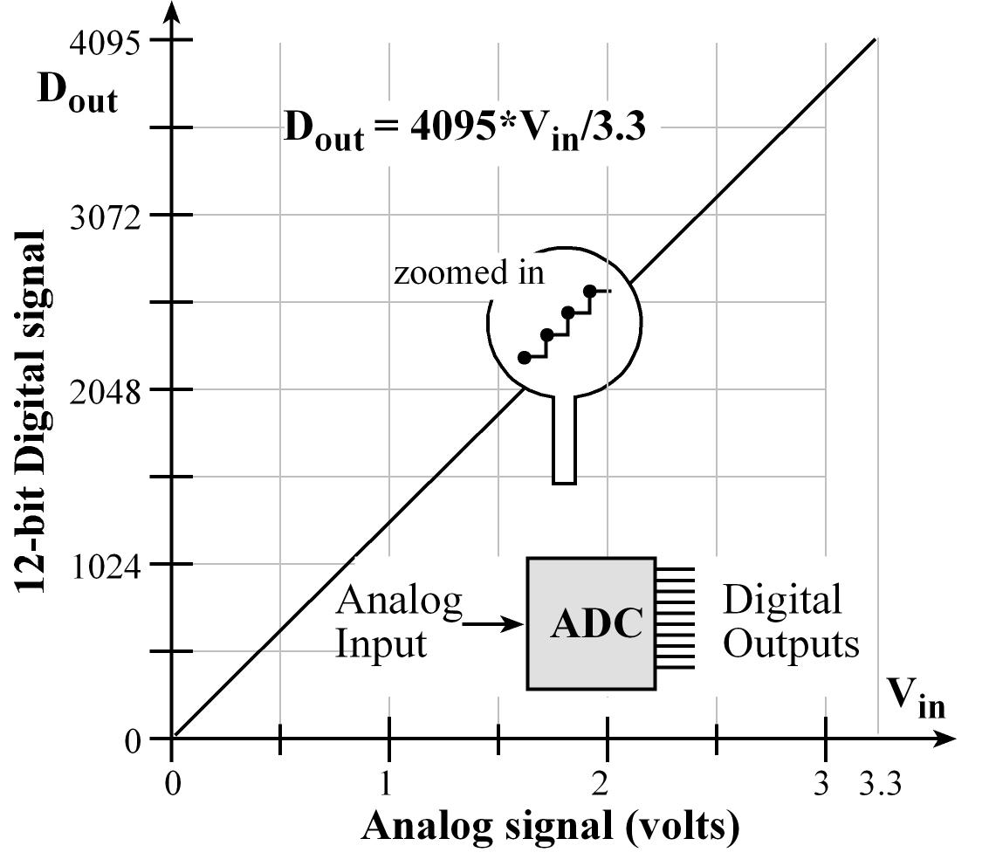
Figure 14.1. A 12-bit ADC converts 0 to 3.3V on its input into a digital number from 0 to 4095.
- Previous
- Next
- About
- Jobs
- Press
- FAQ
- Contact

EdX is a non-profit created by founding partners Harvard and MIT whose mission is to bring the best of higher education to students of all ages anywhere in the world, wherever there is Internet access. EdX's free online MOOCs are interactive and subjects include computer science, public health, and artificial intelligence.
- 

- 

- 

- 

- 
© 2014 edX, some rights reserved.
- Terms of Service and Honor Code

- Privacy Policy

